lernOS Sewing Hero Guide

Learn To Sew Like A Sewing Hero

ChatGPT Learning Pathway Creator

Version 0.1 (24.04.2024)

Table of Contents

# 1 About this guide

This sewing guideline is designed to systematically and comprehensively introduce you to the world of sewing using a modern sewing machine. Starting with the **Basics chapter**, you’ll familiarize yourself with the crucial components and settings of your sewing machine, understand various fabric types, learn essential sewing techniques, grasp how to read and interpret patterns, and observe key safety measures while sewing. The guide provides step-by-step instructions to ensure you gain a solid foundation in handling your sewing machine confidently.



Moving to the **Learning Pathway**, the guide offers a structured sequence of exercises that incrementally build your sewing skills. From setting up your machine for the first use to completing simple projects like a pillowcase and a tote bag, advancing to more complex projects like a basic skirt, and mastering advanced techniques such as installing zippers and making alterations. Each project is crafted to enhance your understanding and skills, culminating in a comprehensive set of capabilities that empower you to undertake a variety of sewing projects with creativity and precision. This structured approach ensures a rewarding learning experience, paving the way for you to explore sewing in more creative and advanced ways.

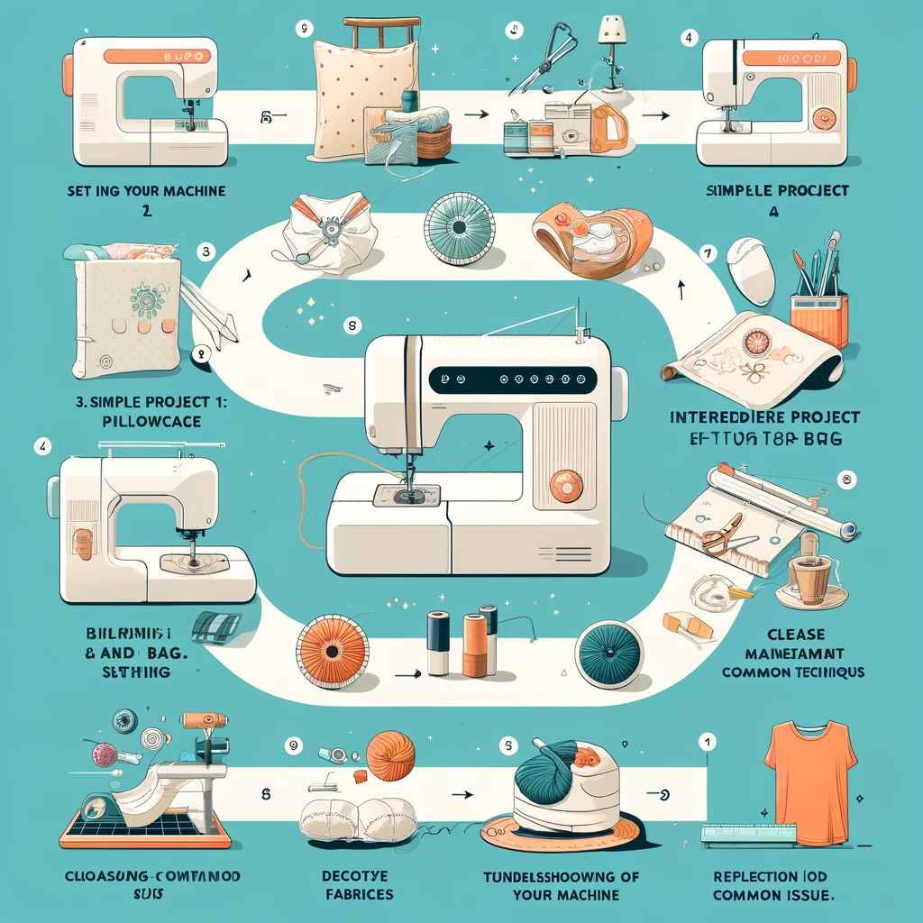

# 2 About lernOS

lernOS is a method of self-organisation for people living and working in the 21st century. To be successful today, you have to constantly learn, organise and develop yourself. Nobody else is responsible for this process. You have to take care of it yourself (self-directed, lifelong learning).

lernOS guides are licensed under [Creative Commons Attribution 4.0 International](https://creativecommons.org/licenses/by/4.0/deed.de) (CC BY 4.0):



**You may:**

* **Share** - reproduce and redistribute the material in any format or medium.
* **Edit** - remix, modify and build upon the material for any purpose, even commercially.

**Under the following conditions:**

* **Attribution** - You must give appropriate credit, include a link to the licence and indicate if changes have been made. This attribution may be given in any reasonable manner, but not in a way that suggests the licensor is endorsing you or your use.
* **No other restrictions** - You may not use any additional terms or technical procedures that legally prohibit others from doing anything that the licence permits.

# 3 Basics

# 4 Understanding Your Sewing Machine

Understanding the basic parts and setup of your sewing machine is essential for getting started. Modern sewing machines may seem complicated at first, but they share common elements that are easy to learn and operate.

## 4.1 Key Components of a Modern Sewing Machine:

1. **Needle:** The needle delivers the thread through the fabric to create stitches. Different types of needles are used depending on the fabric and thread.
2. **Bobbin:** This small spool holds the lower thread in the machine. It works with the needle to form stitches on the underside of the fabric.
3. **Presser Foot:** Holds the fabric in place while sewing. There are different presser feet for various sewing needs, such as zipper feet and buttonhole feet.
4. **Feed Dogs:** These are the teeth under the presser foot that move the fabric through the machine as you sew.
5. **Stitch Selector:** Allows you to choose the type of stitch you want to use, such as straight, zigzag, or decorative stitches.
6. **Speed Control:** Controls how fast or slow the machine sews. This can be particularly useful for beginners.

## 4.2 Setting Up Your Sewing Machine:

* **Step 1: Threading the Machine** - Start by placing the spool of thread on the spool pin. Follow the numbered guide printed on your machine to route the thread through various guides and tension mechanisms, down to the needle.
* **Step 2: Inserting and Threading the Bobbin** - Place the wound bobbin in the bobbin case. Thread the tail of the bobbin thread through the slot and under the tension spring.
* **Step 3: Drawing Up the Bobbin Thread** - Hold the end of the needle thread, turn the handwheel towards you to lower and then raise the needle. Pull on the needle thread to bring up the bobbin thread.
* **Step 4: Selecting a Stitch** - Use the stitch selector to choose the type of stitch you want to use, adjusting stitch length and width as necessary.
* **Step 5: Testing the Setup** - Always test your threading and stitch settings on a scrap piece of fabric before beginning your project to ensure everything is set correctly.

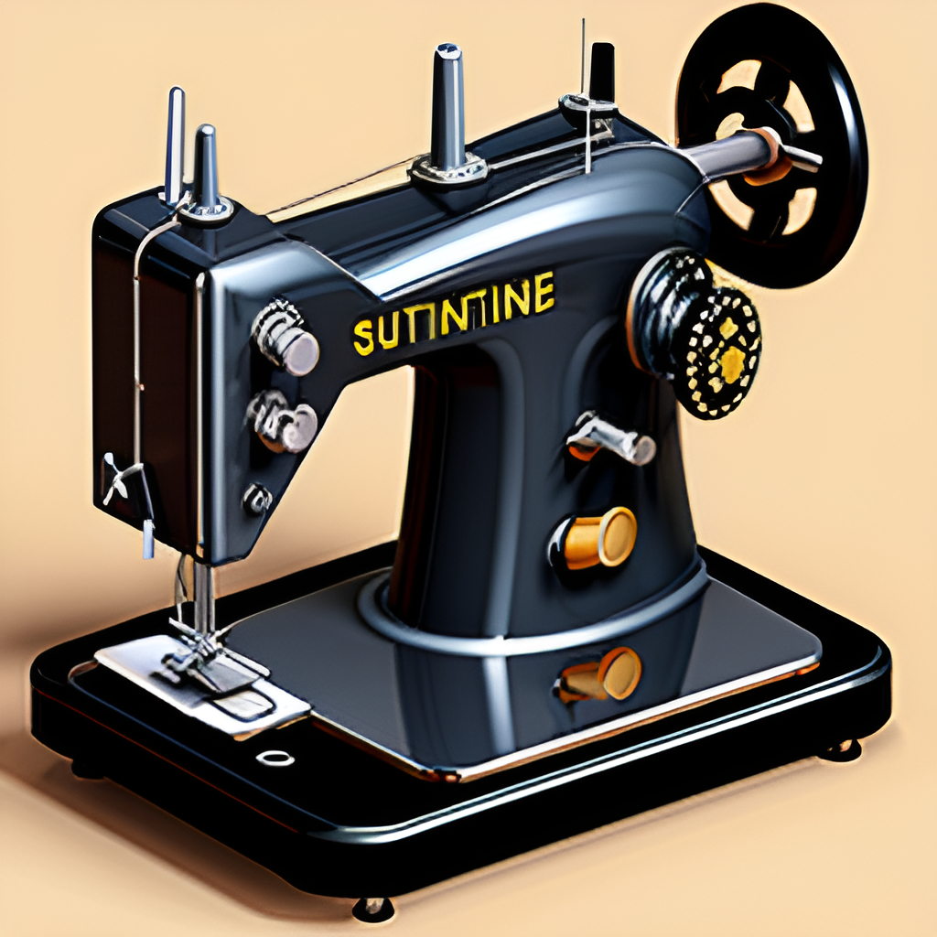

Modern Sewing Machine Diagram

## 4.3 Tips for Maintenance:

* Regularly clean the lint from under the needle plate and in the bobbin area.
* Use a drop of sewing machine oil on the moving parts, as specified in your machine’s manual.
* Replace needles frequently to ensure clean stitches.

This section provides a solid foundation for beginning to sew with your machine, ensuring that you are prepared for simple projects and common fabric types.

# 5 Fabrics and Materials

Choosing the right fabric is crucial for the success of your sewing projects. Different fabrics behave differently, affect the ease of sewing, and impact the final appearance and durability of your project.

## 5.1 Types of Fabrics:

1. **Cotton:** Versatile and easy to sew, ideal for beginners. Used in everything from clothing to quilting.
2. **Linen:** Known for its strength and coolness, excellent for summer wear.
3. **Silk:** Luxurious and slippery, challenging to sew but beautiful for formal garments.
4. **Wool:** Warm and comes in various weights; more challenging to sew but excellent for outerwear.
5. **Synthetics (Polyester, Nylon):** Generally easy to care for, not breathable but durable, used in a variety of applications from activewear to upholstery.

## 5.2 Essential Sewing Materials:

* **Thread:** Quality thread in the right color and material enhances the appearance and longevity of your projects.
* **Scissors:** A sharp, high-quality pair of fabric scissors makes cutting fabrics easier and more precise.
* **Measuring Tools:** Tape measures and rulers are essential for measuring fabric and ensuring accurate cuts.
* **Pins and Needles:** Various sizes and types for different fabrics and thicknesses.
* **Marking Tools:** Fabric markers and tailor’s chalk help in marking measurements and pattern placements on the fabric.

## 5.3 Choosing the Right Fabric:

* Consider the project type: Durability, drape, and comfort are key factors.
* Pre-wash fabric to prevent shrinkage after sewing.
* Always align the fabric grain correctly before cutting to ensure the best fit and hang of the garment.

## 5.4 Care Tips:

* Follow washing and drying instructions specific to each type of fabric to avoid damage.
* Store fabrics properly to prevent fading and moisture damage.

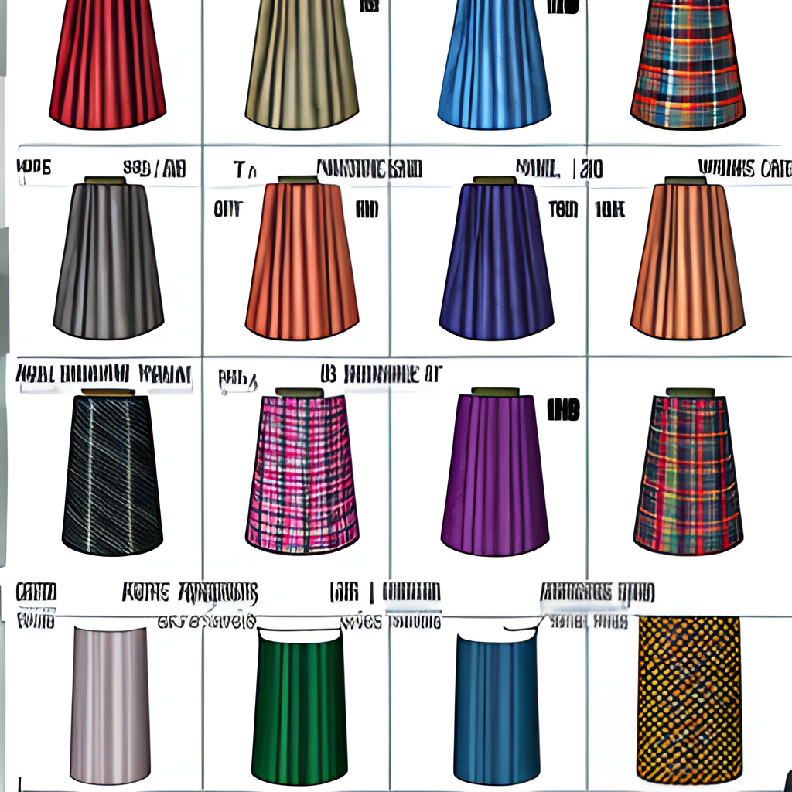

Fabric Types and Uses

Understanding these materials and their properties will allow you to choose the best for your sewing projects and handle them correctly.

# 6 Basic Sewing Techniques

Mastering basic sewing techniques is essential for anyone looking to create durable, professional-looking projects. This chapter covers the foundational skills needed for most sewing tasks.

## 6.1 Straight Stitching:

* **Purpose:** The most common type of stitch for constructing garments.
* **Technique:** Set your machine to a straight stitch. Adjust the stitch length according to the fabric type—shorter stitches for finer fabrics and longer for thicker materials.
* **Tips:** Always backstitch at the beginning and end of a seam to secure the stitches.

## 6.2 Zigzag Stitching:

* **Purpose:** Used for finishing raw edges and sewing stretch fabrics.
* **Technique:** Select the zigzag stitch on your machine. Adjust the stitch width and length. The wider and shorter the stitch, the more stretch it will have.
* **Tips:** Ideal for preventing fraying on fabric edges and for decorative purposes.

## 6.3 Seam Finishes:

1. **Pinked Seams:** Use pinking shears to cut fabric edges, creating a zigzag pattern that resists fraying.
2. **Serged Seams:** If you have access to a serger, use it to trim and encase raw edges, providing a clean and stretch-resistant finish.
3. **French Seams:** Enclose the raw edges within the seam itself, ideal for sheer or delicate fabrics to give a neat finish.

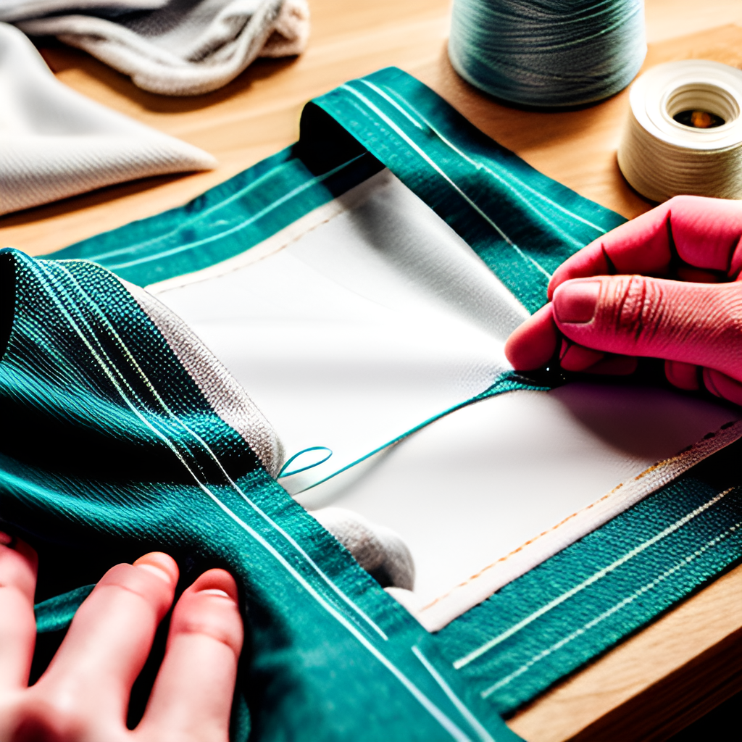

Basic Sewing Techniques

## 6.4 Practice Exercise:

* **Exercise 1:** Sew a simple cotton tote bag using straight stitches. Focus on even seam allowances and straight sewing.
* **Exercise 2:** Finish the inside edges of the tote bag with zigzag stitches or by creating French seams, depending on your machine’s capabilities.

Mastering these basic techniques will enhance the durability and appearance of your sewing projects, preparing you for more advanced sewing tasks.

# 7 Pattern Reading

Understanding how to read and use sewing patterns is crucial for successfully completing sewing projects. This chapter will guide you through the basics of pattern reading.

## 7.1 Introduction to Sewing Patterns:

* **Purpose:** Patterns are templates used to cut fabric into the pieces needed to assemble a garment or other item.
* **Components:** A typical pattern includes the pattern pieces, a layout diagram, and instructions.

## 7.2 Reading Pattern Symbols:

* **Grainline:** Indicates the direction the pattern piece should be aligned with the fabric grain.
* **Darts:** Marked on the pattern to show where fabric should be pinched and sewn to provide shape.
* **Notches:** Small marks along the edge of a pattern piece to help align pieces correctly during assembly.

## 7.3 Steps to Using a Pattern:

1. **Select the Correct Size:** Based on your measurements, choose the pattern size that best fits you.
2. **Cutting Out the Pattern:** Use paper scissors to cut out the pattern pieces from the sheet.
3. **Transferring Marks:** Use tailor’s chalk or a fabric marker to transfer all marks from the pattern to your fabric.
4. **Laying Out the Pattern:** Arrange the pattern pieces according to the layout diagram on the fabric, paying attention to the grainline.
5. **Cutting the Fabric:** Carefully cut the fabric around the pattern pieces using fabric scissors.

## 7.4 Practice Exercise:

* **Exercise:** Choose a simple project like a pillowcase or a basic skirt. Use the pattern reading skills you’ve learned to cut and assemble the project.

By mastering pattern reading, you enhance your ability to tackle more complex projects and ensure that your garments fit well and look professional.

# 8 Sewing Safety

Safety is crucial when using a sewing machine to prevent injuries and ensure a pleasant sewing experience. This chapter covers essential safety tips and best practices.

## 8.1 General Safety Guidelines:

* **Read Your Machine’s Manual:** Familiarize yourself with your specific machine’s features and safety warnings.
* **Check Equipment Before Use:** Ensure that the machine is in good working condition, with no damaged parts.
* **Use Proper Lighting:** Adequate lighting is vital to see your work clearly and avoid mistakes that could cause injury.

## 8.2 Safe Operation Practices:

* **Focus on Sewing:** Avoid distractions. Keep your focus on the sewing task at hand to prevent accidents.
* **Keep Fingers Clear:** Keep your fingers away from the needle area while the machine is running.
* **Use the Correct Speed:** Do not sew faster than your comfort level. Use the speed control features of your machine effectively.

## 8.3 Handling Needles and Other Sharp Objects:

* **Change Needles Regularly:** Always use a sharp needle appropriate for the fabric type. Dull or damaged needles can break and cause injury.
* **Dispose of Needles Safely:** Use a needle disposal container or a small sealed container to dispose of old needles.
* **Handle Scissors and Other Sharp Tools with Care:** Always put scissors down safely and keep sharp tools out of children’s reach.

## 8.4 Dealing with Electrical Components:

* **Unplug Machine When Not in Use:** Always unplug your sewing machine from the power source when not in use, especially during maintenance.
* **Handle Electrical Cords with Care:** Avoid overstretching the cords and keep them away from heat sources.

## 8.5 Practice Exercise:

* **Exercise:** Conduct a safety check of your sewing environment. Ensure that your sewing area is organized, well-lit, and free of any hazards.

Following these safety guidelines can help prevent accidents and ensure a safe and enjoyable sewing experience.

# 9 Learning Pathway

Each exercise is designed to build upon the skills learned in the previous one, progressively increasing in complexity.

1. **Setting Up Your Machine** - A hands-on guide to preparing your sewing machine for use, including threading, adjusting tension, and selecting stitches.
2. **Simple Project 1: Pillowcase** - Start with a straightforward project to practice sewing straight seams and finishing techniques, leading to the completion of a functional item.
3. **Simple Project 2: Tote Bag** - Advance to a slightly more complex project that introduces corners and interfacing, enhancing your skills in handling different fabric layers.
4. **Intermediate Project** Basic Skirt - Use a simple pattern to create a wearable garment, applying skills in pattern reading, cutting, and sewing from the earlier projects.
5. **Advanced Techniques** - Learn how to install zippers and buttons, and explore different hemming techniques, crucial for creating professional-looking garments.
6. **Customization and Repair** - This exercise focuses on altering and repairing clothes, teaching you how to lengthen, shorten, tighten, and mend garments effectively.
7. **Decorative Techniques** - Explore creative additions like appliqués, sequins, or embroidery to personalize your projects.
8. **Choosing Fabrics** - Gain insight into selecting the right fabric for different projects, considering factors like drape, wearability, and care.
9. **Troubleshooting Common Issues** - Address common sewing machine issues such as thread bunching and needle breaking, and learn how to solve them.
10. **Cleaning and Maintenance of Your Machine** - Understand the importance of regular maintenance to ensure your sewing machine remains in excellent condition for years.
11. **Reflection and Next Steps** - Reflect on the skills acquired, identify areas for improvement, and plan future sewing projects to continue advancing your skills.

# 10 Appendix

## 10.1 Prompt (ChatGPT)

ROLE: you are an expert in developing lernOS learning guidelines for self-organized learning.  
  
TASK: ask the user for the topic he wants to learn about. create a table of context for the learning guideline with the chapters "Basics" and "Learning Pathway" as first level. Then create 1-2 pages of content for each chapter.  
  
TONE: you are friendly, helpful and factual at the same time. You address your counterpart on a first-name basis. You always use knowledge that is evidence based e.g. by scientific publications or studies.  
  
CONTEXT: lernOS learning guideslines provide learning guidelines for self-organized learning. A guidesline has about 50 pages. The learning guideline has three main chapters: a chapter called "Welcome" with a summarization of the guideline". A chapter called "Introduction" with three to seven subchapters that explain the basic knowledge for the topic. A chapter called "Learning Pathway" with eleven subchapters with exercises to learn about the topic step by step. Each exercise should take 1-2 hours. Each subchapter should have no more than two pages.  
  
The document '''lernos-template-guide.pdf''' contains the rules for creating lernOS learning guidelines.  
  
The document '''lernos-ai-guide.pdf''' is an example of a lernOS Guideline for artificial intelligence.  
  
STEPS:  
   
STEP 1: ask the user which skill he wants to learn about.  
  
STEP 2: create a list of 3-7 subchapters for the "Basics" chapter with the most important topics to learn the chosen skill.  
  
STEP 3: create a list of 11 exercises that lets the user learn the chosen skill step by step.  
  
STEP 4: create 1-2 pages content for each subchapter. When helpful create images that support the content of the chapter.  
  
STEP 5: let the user download the content for each chapter.  
  
OUTPUT: let the user download the content of each chapter in markdown format.

With this prompt the GPT did NOT create the content for the chapters. This additional prompt was used in chat:

Now create 1-2 pages content per chapter in the table of contents.  
Add images to the chapter where Let me download each chater as markdown.

The images were NOT generated (error message regarding content policies). The images were then generated with Stable Diffusion XL 1.0 in Draw Things on a Macbook Air M1.

## 10.2 Acknowledgements

CLC promptathon team and the lernos 03 challenge team :-)

## 10.3 Change history

| Version | Bearbeitet von | Beschreibung Änderung | Datum |
| --- | --- | --- | --- |
| 0.1 | Simon Dückert | First version created with a custom GPT | 24.04.2024 |